To establish learning ambience for ushering in computer engineering professionals in core and multidisciplinary area by developing Problemsolving skills through emerging technologies.

Session | 2025-26 (ODD) | Course Name | Operating System Lab
Semester | 5 | Course Code | 23IOT1504
Roll No | 37 | Name of Student | Dhanashri Raut

Practical Number | 7
Course Outcome | - Understand Computer System Configuration and Simulate system resources efficiently using Linux Commands (CO1)  - Analyse operating system functionalities utilizing system calls, thread programming and process scheduling algorithms (CO2)  - Apply Synchronization primitives to implement a Deadlock-free solution(CO3)  - Simulate Disk scheduling, Memory allocation, File allocation, page replacement algorithms (CO4)
Aim | Implement a program to simulate Disk Scheduling Algorithms  - First Come First Serve (FCFS)  - Shortest Seek Time First (SSTF)
Problem Definition | To simulate and compare the performance of FCFS and SSTF Disk Scheduling Algorithms by calculating the total head movement for a given sequence of disk requests and an initial head position.
Theory | Disk scheduling algorithms determine the order in which I/O requests are serviced to minimize seek time (the time the disk arm takes to reach a requested track).  1. First Come First Serve (FCFS):  - Requests are served in the order they arrive.  - Simple and fair but may result in high average seek time.  Advantages:  - Easy to implement.  Disadvantages:  - Not optimal; may cause long delays for distant requests.
To establish learning ambience for ushering in computer engineering professionals in core and multidisciplinary area by developing Problemsolving skills through emerging technologies.

2. Shortest Seek Time First (SSTF):
- The request with the minimum seek time from the current head position is served next.
- Reduces total head movement compared to FCFS.
Advantages:
- More efficient; reduces seek time. Disadvantages:
- May cause starvation of far requests.

Key Formula:
Seek Time ∝ Total Head Movement
1. Total Head Movement = ∑ ∣ Current Track − Next Track ∣

Give Procedure and Execution  (100 Words) | 1. 2.  3. | Input the number of disk requests and the initial head position.  Enter the sequence of requested tracks.  For FCFS: Service requests in order of arrival and calculate total head movement.
 | 4. | For SSTF: From the current head position, find the nearest request, service it, and repeat until all requests are complete.
 | 5. | Display the sequence of servicing and total head movement for each algorithm.
 | 6. | Compare the two algorithms for efficiency.
Code for FCFS:
#include <stdio.h> #include <math.h>
int main() { int n, i;
printf("Enter Number Of Indexes: "); scanf("%d", &n); int arr[n]; int head;
int seek_count = 0, cur_track, distance; printf("Enter The Indexes Of Requested Array:\n"); for (i = 0; i < n; i++) {
scanf("%d", &arr[i]);
}
printf("Enter Head: "); scanf("%d", &head);
To establish learning ambience for ushering in computer engineering professionals in core and multidisciplinary area by developing Problemsolving skills through emerging technologies.

for (i = 0; i < n; i++) { cur_track = arr[i]; distance = fabs(head - cur_track); seek_count += distance; head = cur_track;
}
printf("Total number of seek operations: %d\n", seek_count); return 0;
}

Code for SSTF:
#include <stdio.h>
#include <stdlib.h>

int main() {
int n, i, j;
printf("Enter Number Of Indexes: "); scanf("%d", &n);

int arr[n]; int head;
int seek_count = 0; int distance, min_distance, index; int completed[n];

printf("Enter The Indexes Of Requested Array:\n"); for (i = 0; i < n; i++) { scanf("%d", &arr[i]);
completed[i] = 0;
}

printf("Enter Head: ");
scanf("%d", &head);

printf("\nSeek Sequence:\n");

for (i = 0; i < n; i++) { min_distance = 100000;
index = -1;

for (j = 0; j < n; j++) { if (!completed[j]) { distance = abs(head - arr[j]); if (distance < min_distance) {
To establish learning ambience for ushering in computer engineering professionals in core and multidisciplinary area by developing Problemsolving skills through emerging technologies.

min_distance = distance;
index = j;
}
}
}

seek_count += min_distance;
head = arr[index];
completed[index] = 1;

printf("%d ", head);
}

printf("\nTotal number of seek operations: %d\n", seek_count);

return 0;
}

Output For FCFS:
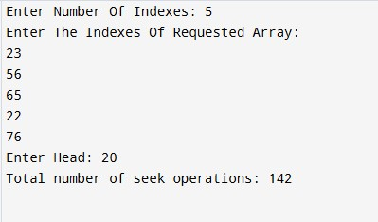

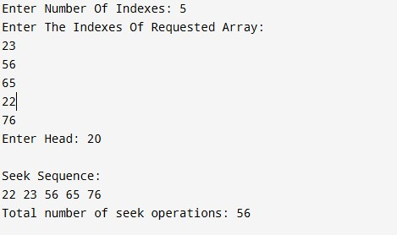Output For SSTF:
To establish learning ambience for ushering in computer engineering professionals in core and multidisciplinary area by developing Problemsolving skills through emerging technologies.

Output Analysis | For the given input, SSTF performed better than FCFS because it always services the nearest request first, minimizing the total head movement.  Thus, SSTF is more efficient in reducing seek time and improving disk performance, though it may lead to starvation in some cases.
Link of student Github profile where lab assignment has been uploaded | https://github.com/24030192-lab/-OS-Practicals
Conclusion | Successfully implemented FCFS and SSTF Disk Scheduling Algorithms.  Observed that SSTF achieves lower total head movement compared to FCFS, proving to be more efficient for disk access optimization.
Plag Report  (Similarity index <  12%) | 
Date | 27/10/25

